Japanese Traditional Music
Shakuhachi & Koto
Concert
7 p.m. 18 June 2007
Slovene Ethnographic Museum
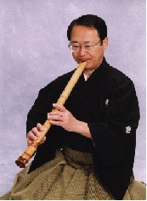
Ｔａｄａｓｈｉ Ｔａｊｉｍａ
Tadashi Tajima, shakuhachi player, born in Osaka, is credited with popularizing and increasing the awareness of shakuhachi, which is a Japanese recorder made of bamboo. He won the grand prize for traditional Japanese music at the Pan Music Festival and the achievement award for Osaka's Theatrical and Musical Arts Organization. His worldwide concert tours were tremendously successful.
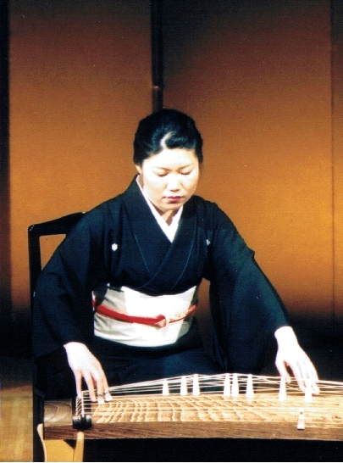
Ｎｏｒｉｋｏ Ｈｉｒａｔａ
Noriko Hirata, born in Osaka, is a celebrated koto player of great brilliance. Already at a very young age, she showed an outstanding musical talent for koto, a traditional wooden instrument. Through many recitals all across Japan, radio and TV broadcasts as well as recordings, she helped to make Japanese traditional koto music familiar to the Japanese public.

Information: 01 -200 -82 -82 ( Embassy of Japan )
Admission: Free

* The number of seats is limited, We will accept 50 applications on the first come basis,
info@embjp.si or by phone: 01 -200 -82 -82

